**MODEL VIEW:**

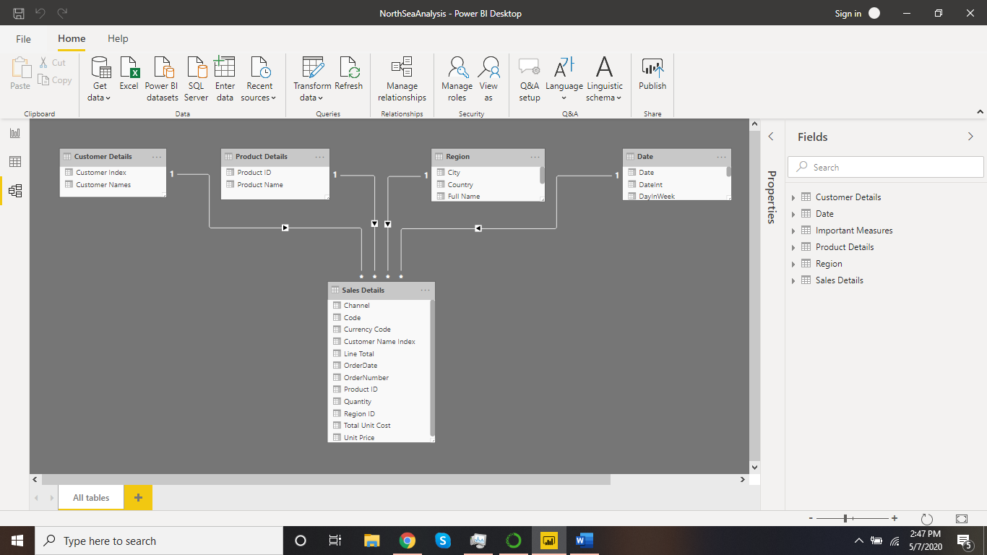

**DATA VIEW:**

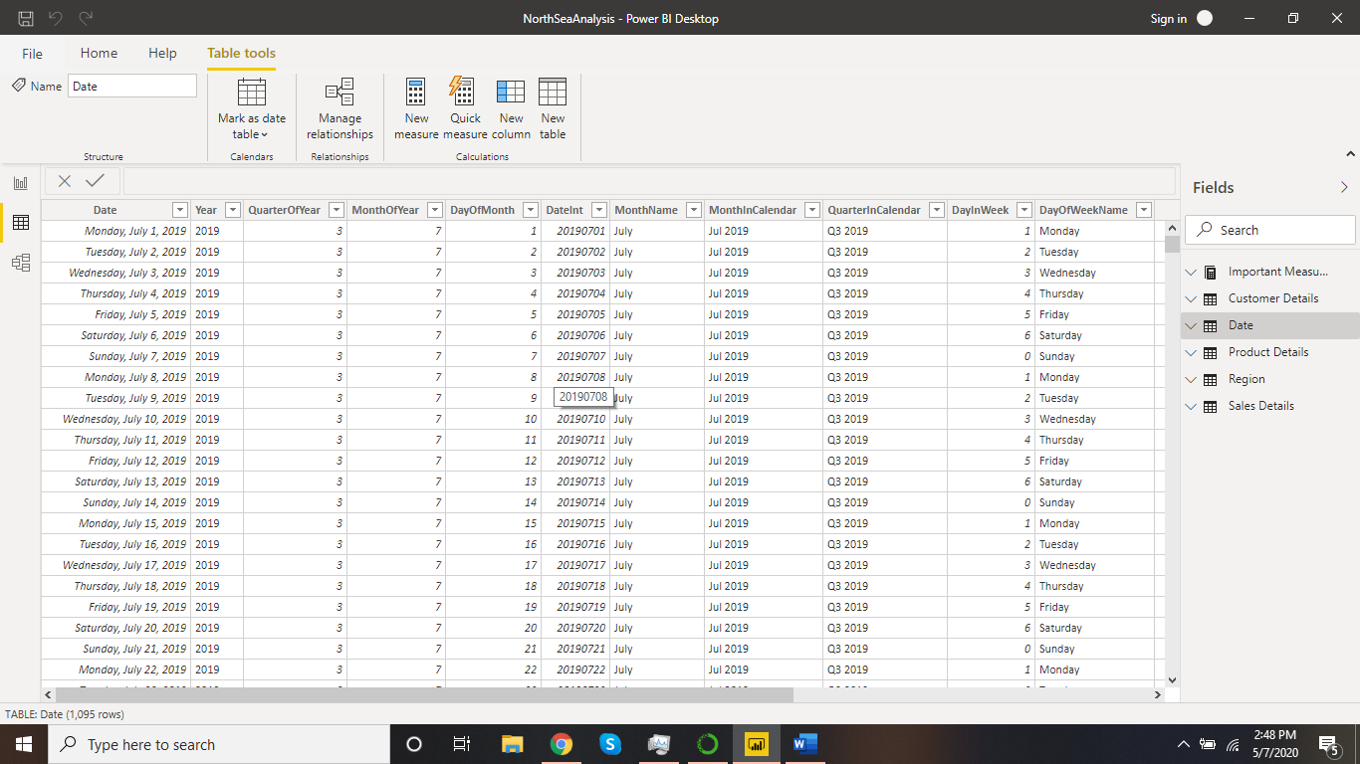

**REPORT VIEW:**

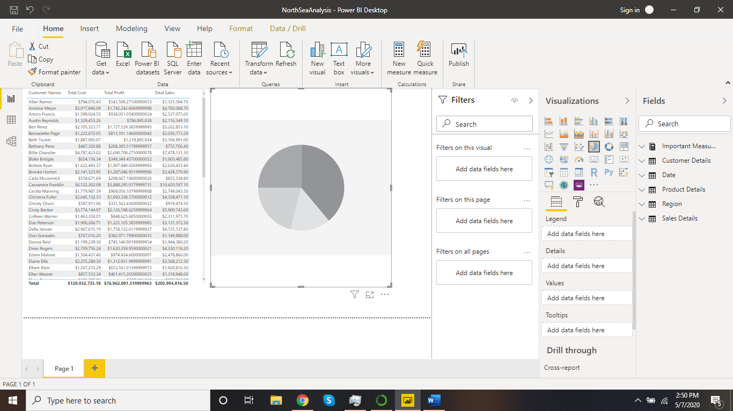

**PRICES OF :**

**FREE − Power BI Desktop**

**$9.99− Power BI Pro**

**$4995− Power BI Premium**